**Week 4**

**NAME:HASHIR KHAN**

**ID: TN/IN01/PY/007**

**DOMAIN:PYTHON**

**Task 1**:

Step 1: Ask the user to enter something



Step 2: Show the data type using type()

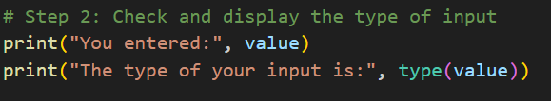

Step 3: Ask the user to enter a Python command

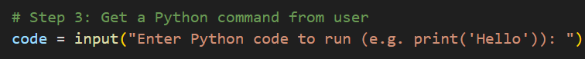

Step 4: Run the Python command using exec()

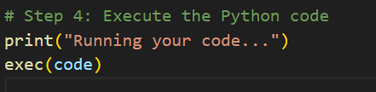

Output:

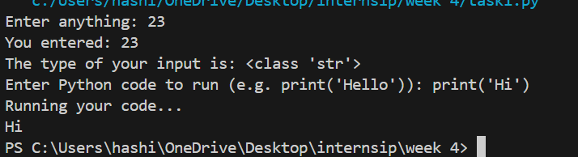

* Task 2:

Step 1: Ask the user to enter an expression



Step2 Store it in a result variable using exec



Step3 Show the result



Output:

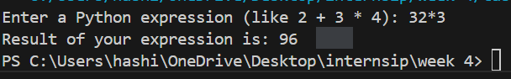

TASK 3

Step 1: Import the math module



Step 2: Ask user to enter the radius



Step 3: Calculate Area of Circle

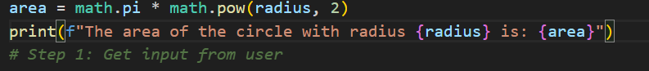

Output:

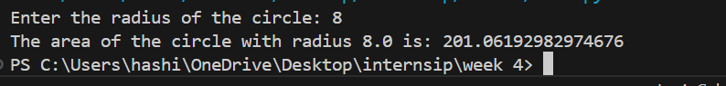

Step 4: Calculate Circumference



Output



Task4

**Step 1: Import required modules**



Step 2: Combine all character types



Step 3: Randomly pick 8 characters



# Step 4: Show the password



Ouput



Task 5:

Step 1: Import the module



Step 2: Ask user for their birthdate



Step 3: Convert input string to a date



Step 4: Get the current date



Step 5: Calculate number of days lived



Step 6: Calculate age in years



Step 7: Show the result

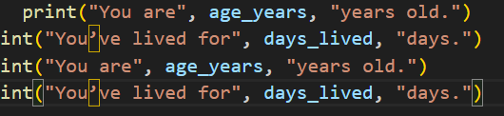

Ouput

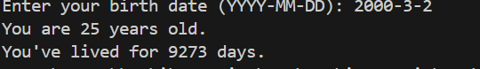

Task 6

Step 1: Import required modules



Step 2: Get list of files in the folder 

Step 3: Create a pattern using regular expression 

Step 4: Filter only .txt files that match the pattern 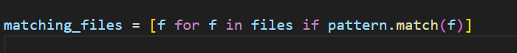 Step 5: Show the results

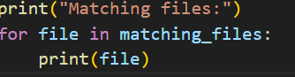

Ouput

